**Assignment 1B -** Team analysis Belbin team roles

The Belbin Team Role reports help you to understand the behavioral characteristics people can display when you are working with them in a team. Each Belbin Team Role offers a different style of contribution to the team. With an understanding of these styles, you and your team can work and interact more effectively! Please read the chapter ‘Belbin Teamroles’ in TU Teamwork for more information.

***This exercise is aimed to give you a better understanding of the contributions you AND your team members make to the team.***

The next step, after your individual analysis, is to share your Team Role profile with other members of the team and encourage them to do the same. Bear in mind that we all have different strengths and weaknesses.

Please answer the following questions:

1. List all the team members' learning objectives (see Assignment 1A).

* Lucian Negru: In this course I would like to complete all my sprint tasks by the end of every single week and even have time to offer help to my teammates if need be.
* Radu Constantinescu: In this course, I would like to develop academically, by trying new technologies and things which I have not seen before. I want to embrace and change a bit my attitude towards work. So be also more like a coordinator while being a good team worker and a resource investigator in the following 2 months.
* Kendra Sartori: In this course I would like to expand my knowledge by asking more questions and communicating effectively with teammates and professionals with more knowledge than me, in the next two months.
* Ahmed Ibrahim: In this course I want to improve my data science skills by implementing a deep learning algorithm in the following two months.
* Manar Al-Robayi: I want to substantially improve my programming skills in Python in the upcoming two months.

1. Which team roles are presented in your project group? Write down the top 3 of each team member in the figure below:

* Lucian Negru: Implementor, Coordinator, Specialist
* Radu Constantinescu: Implementor, Monitor Evaluator, Complete Finisher
* Kendra Sartori: Shaper, Monitor Evaluator, Plant
* Ahmed Ibrahim: Implementor, Shaper, Monitor Evaluator
* Manar Al-Robayi: Monitor Evaluator, Team worker, Implementor

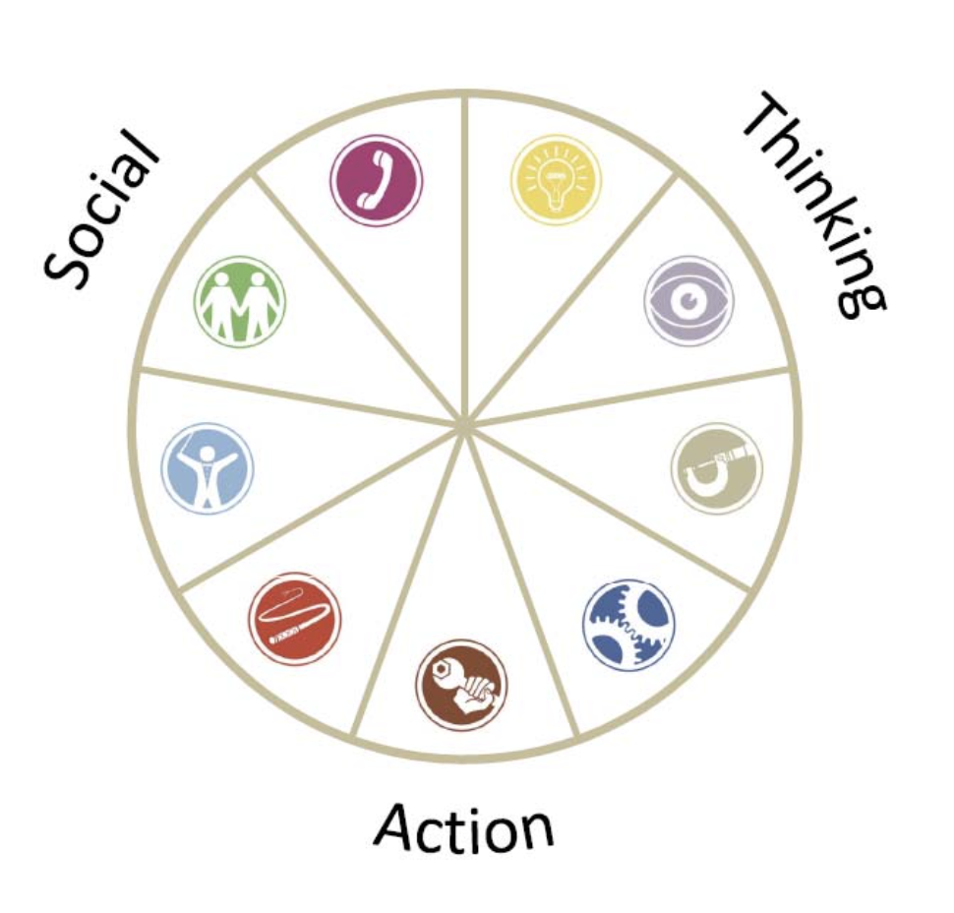

1. The combination of team roles influences the performance of your team.

What could be, according to you, the possible strengths and possible weaknesses of your team?

Team strengths:

After taking the Belbin test, the team roles are evenly spread between implementer, monitor evaluator and shaper. Thus, we possess many of the do’s that will ensure that our team will have a proper organization system to ensure that ideas are turned into action while supporting each other and providing balanced opinions on other’s ideas. Since there are Shapers, we will strive for the process to be honest and transparent.

Team weaknesses:

After seeing the result of the Belbin team roles for the group, we can observe that we have 4 implementers and 4 monitor evaluators yet some roles are almost absent such as team worker, plant or complete finisher. This makes us prone to weaknesses such as resistance to new ideas, overly critical. Furthermore, we lack the do’s of some roles such as the creativeness of a plant, the attention to detail of a complete finisher and the ability to work in a team environment as a team worker.

1. What can you do to compensate for the weaknesses of the team?

Have frequent meetings and discussions weighing all ideas and issues, and ultimately come up with a solution. We can also try and combine the team meeting together with the meeting with the company in order to make everything more efficient. In addition to this, we will compensate for the lack of the missing team role assets.

1. Write down your *team learning goal* for this project. Make sure it is SMART (**S**pecific, **M**easurable, **A**chievable, **R**elevant and **T**imebound)

Our main team objective is to gain the data science experience and work on a project in a real working environment while delivering a product which satisfies all of the requirements set by us in agreement with the client by the end of the ten weeks.